
Running NuPAGE Pre-cast SDS-PAGE Gradient Gels

IMPORTANT GENERAL REMARK:

- NuPAGE pre-cast gradient gels are sensitive for overloading and impurities/undissolved particulates. Adding extra sample buffer (1xconcentrated) helps dissolving your sample better.
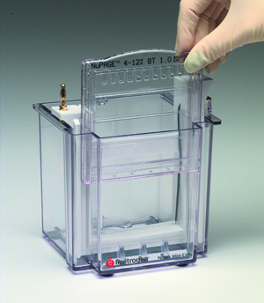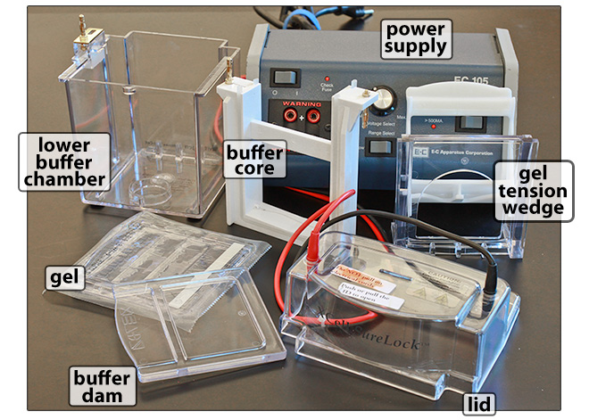
http://brianmccauley.net/Bio6B/index.php/protein-electrophoresis-lab/sds-page-method

Method
A. Sample Preparation
- To run your samples you should have your sample as a mixture that contains:
- 65% (v/v) sample
- 10% (v/v) 1M DTT
- 25% (v/v) 4xNuPAGE® LDS Sample Buffer
(e.g. 65 µl sample + 10 µl 1M DTT + 25 µl 4xLDS Sample Buffer)
To particulates (cell pellets, tissue fragments), you can add 1xconcentrated sample buffer
(three components as above, but replacing sample with MilliQ water).
- Boil or heat your samples (90-100 ºC) for 3 minutes.
- Samples can be stored at -20 ºC or -80 ºC prior to SDS-PAGE.

B. Preparing the Running Buffer
- Transfer 40 ml NuPAGE® 20xMES buffer to a graduated measuring cylinder, and add cold MilliQ water to a volume of 800 ml. Mix the solution with a magnetic stirring bar and stirrer.
- Vortex the NuPAGE® Antioxidant for a few minutes to dissolve precipitaties.
- Take 200 ml of the mixture prepared in step 4, and add 0.5 ml Antioxidant. Mix the solution with a magnetic stirring bar and stirrer.

C. Installing the Gel(s) into the XCell SureLock® Mini-Cell Unit
- Open a gel cassette pouch with scissors, pour off gel packaging buffer into the sink.
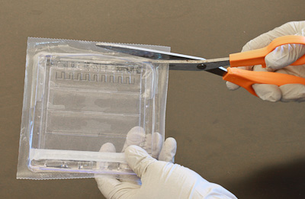

WEAR GLOVES AT ALL TIMES

ACRYLAMIDE IS NEUROTOXIC

- Take the gel cassette from the pouch, and rinse the outside of the cassette with Milli-Q water.
Carefully dry the cassette with lint-free tissue.
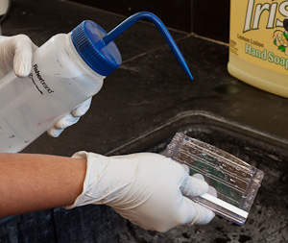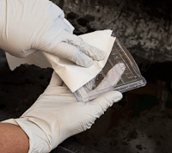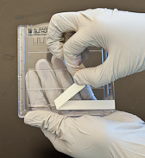
- Peel off the tape covering the slot on the back of the cassette. If you forget to do this, your gel will not run run at all. During the run, electricity must pass through the gel, and this slot makes contact with the running buffer to create an electrical circuit.
- In one fluid motion carefully pull the comb out of the gel, creating/opening the wells.
The comb has formed the wells into which you will load your samples.
Delicate 'stalks' or 'fingers' separate the individual wells of the gel; removing the comb too harshly may destroy these stalks and therefore cause loss of wells! The stalks should be upright.
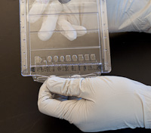
- With a pipette, gently wash the wells 3x with Running Buffer. Drain the wells each time by inverting the gel cassette and shaking. Fill the wells with Running Buffer and remove air bubbles.
- Lower the Buffer Core into the Lower Buffer Chamber in such a way that the gold banana plug ('terminal') of the former fits into the opening of the gold connector plate of the latter.
See next page.

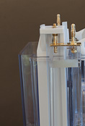
- Insert the Gel Tension Wedge (see below, left) into the Lower Buffer Chamber, behind the Buffer Core and with its white lever facing the rear of the Lower Buffer Chamber (see below, right). Both the Buffer Core and the Gel Tension Wedge should rest on the bottom of the Chamber.

- Place the gel cassette in front of the Buffer Core (see above, middle & right) in the Lower Buffer Chamber, with the shorter plate facing in (i.e., towards the Buffer Core), and the longer plate (with text labelling "NuPAGE 4-12% .." at the top) and its open slot at the bottom facing out. Place another gel cassette at the other side of (behind) the Buffer Core, or,
if you run only one gel, use the Buffer Dam:
- Make sure the gels, or gel and Buffer Dam, are snug against the Buffer Core (form a tight seal with the silicone gaskets of the Core). Press down on the Buffer Core/gel assembly, and pull the Gel Tension Wedge lever forward (towards the Buffer Core) until it comes to a firm stop.
This locks the gels (or gel and Buffer Dam) against the Buffer Core, and should create a leake-free inner chamber referred to as the Upper Buffer Chamber.
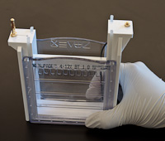 Upper Buffer Chamber (removed from the Lower Buffer Chamber here)

- Fill the Upper Buffer Chamber with 200 ml cold 1 x NuPAGE MES SDS Running Buffer to
which 500 µl NuPAGE Antioxidant has been added (this will prevent re-formation of disulfide
bridges between cysteines during gel electrophoresis). The buffer should completely cover the gel wells, i.e., its surface level should reach between the respective tops of the short and long plates of
the gel cassette(s). If the buffer is not in contact with the gel, no current will flow!
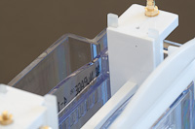
buffer level should be between the top of the long plate (facing out) and the top of the short plate (facing in)
- Check if there is no buffer leakage from the Upper Buffer Chamber into the Lower Buffer Chamber.
If so, return to step 13.
- Spin your denatured samples (see section A) for 5-10 min at full speed in a microcentrifuge.
- Take 35 µl supernatant, or if less sample is to be loaded, add 1xconcentrated sample buffer to bring the final volume to 35 µl.
- Load 35 µl of samples, and 5 µl of prestained moleculer weight marker (SeeBlue® Plus2).
Fill unused wells with 1xconcentrated sample buffer.

Loading could be done with ordinary 200-µl tips (from the top of the well, allowing the sample to "sink" to the bottom of the well), but use of finer gel loader tips (that can be inserted into the well to load at the bottom) is recommended.

- Fill the Lower Buffer Chamber by pouring 600 ml cold Running Buffer (no Antioxidant) through the gap between the Gel Tension Wedge lever and the rear of the Lower Buffer Chamber.
Filling the Lower Buffer Chamber to a large extent is recommended; the buffer should at least cover the slot at the bottom of the longer plate of gel cassettes to establish an electrical circuit.
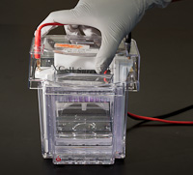

- Place the lid on the Buffer Core, properly aligning the two banana plugs, and gently press
down till the lid is seated. This can be done in only 1 orientation: front of the lid (with text
labelling "XCell SureLock..") and front of the Lower Buffer Chamber facing in the same direction.
The black cable is connected to the right plug (connected to the platina wire on the inside of the Buffer Core, making it the negative electrode), and the red cable is connected to the left plug (connected to the platina wire on the outside of the Buffer Core, making it the positive electrode).
The negatively charged proteins will run towards the latter: "RUN TO RED".
- Insert the other jacks of the cables into the proper (colour-coded) position of a power supply that is turned off, linking the red cable to the positive pole, and the black cable to the negative pole.
- Turn on the power: run at 200 V (constant voltage) for ~ 50 min. Check (in time) whether the dye front has run far enough (in general to ~ the bottom of the gel). The electric current should start at 100-125 mA, and gradually decrease to 60-80 mA at the end of the run.
Based on the pre-stained marker you can also follow progression of the run and establish which molecular weight is at the bottom of the gel (if you would allow a certain size range to run off).
- Turn off the power supply and disconnect the cables, then remove the lid.
- In the sink, unlock the Gel Tension Wedge and remove it. The buffer leaks out of the Upper Buffer Chamber as the gels (or gel & Buffer Dam) no longer make a tight connection with the Buffer Core.
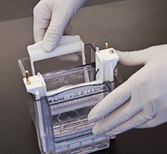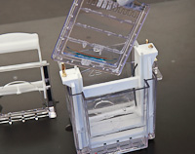
- Remove the gel cassette and place it on a paper towel, with the longer plate down and the shorter plate up, and the cassette protruding ~ 1cm from the bench. Use a Gel Knife to separate the plates
at the outside of the cassette by inserting the edge of the Gel Knife between the shorter and longer plates, and carefully moving the Gel Knife up and down.
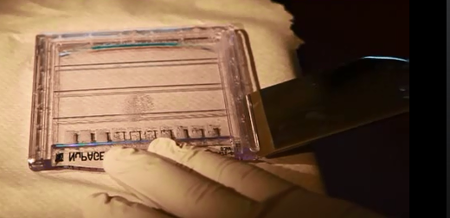
Gel Knife
It takes some leverage to completely break the plastic welds (making an eerie cracking sound) and separate the plates. Do this all the way around (i.e., both sides and the bottom of the cassette), so that you can slowly lift the short plate off. Allow the gel to peel off from the shorter plate.
The gel will usually stick to the longer plate due to a "foot" of gel material sticking into the slot that served to make buffer contact. For MS: STAY AWAY FROM THE GEL WITH FACE/ARMS ETC.: KERATIN!
- Above a keratin-free tray with ~ 50 ml Fixing Solution, quickly invert the plate (gel facing down), and use the Gel Knife to gently push the gel foot out of its slot. Fix,and go on with Coomassie staining.

Solutions
  - 1 M DTT:
● weigh 0.154 g DTT (dithiothreitol)
● dissolve in 1 ml MilliQ water.

  - NuPAGE solutions (ready-made):
● NuPAGE® LDS Sample Buffer (4X), Life Technologies cat. no. NP0007
Final (1x) will be:
106 mM Tris-HCl
141 mM Tris
2% LDS
10% glycerol
0.51 mM EDTA
22 mM SERVA Blue G250
0.175 mM Phenol Red, pH8.5
● NuPAGE® MES SDS Running Buffer (20X), Life Technologies cat. no. NP0002
Final (1x) will be:
50 mM Tris
50 mM MES
0.1% SDS
1 mM EDTA, pH 7.3
● NuPAGE® Antioxidant, Life Technologies cat. no. NP0005
● SeeBlue® Plus2 Pre-stained Protein Standard, Life Technologies cat. no. LC5925.

  - Fixing Solution:
● 50% (v/v) ethanol
● 3% (w/v) phosphoric acid (H₃PO₄)

Materials & Equipment
- XCell SureLock® Mini-Cell Unit and accessories
- NuPAGE® Bis-Tris Precast Gels, selected from:
● NuPAGE® 4-12% Bis-Tris Protein Gels, 1.0 mm, 10 well (Life Technologies, cat. no. NP0321BOX)
● NuPAGE® 4-12% Bis-Tris Protein Gels, 1.5 mm, 10 well (Life Technologies, cat. no. NP0335BOX)
- Gel Loader Tips
- Gel Knife
- Keratin-free tray

