
Running 'Blob Gels':
Sample clean up using SDS-PAGE without separation

'Blob gels' are so named because in this procedure, protein mixtures are only allowed to traverse the stacking gel and then (completely) enter the beginning of the separating (resolving) gel, after which the run is already stopped. After staining with Coomassie Blue, the proteins should appear as an ~ unseparated blue ‘blob’ just below the stacking gel.
This SDS-PAGE application can be used to clean up protein mixtures, removing other molecules and ions, without actually separating the protein mixture along a whole gel lane. It is an advantageous method for cleaning up protein mixtures that should/can be analyzed as a whole in a single LC-MS/MS run.
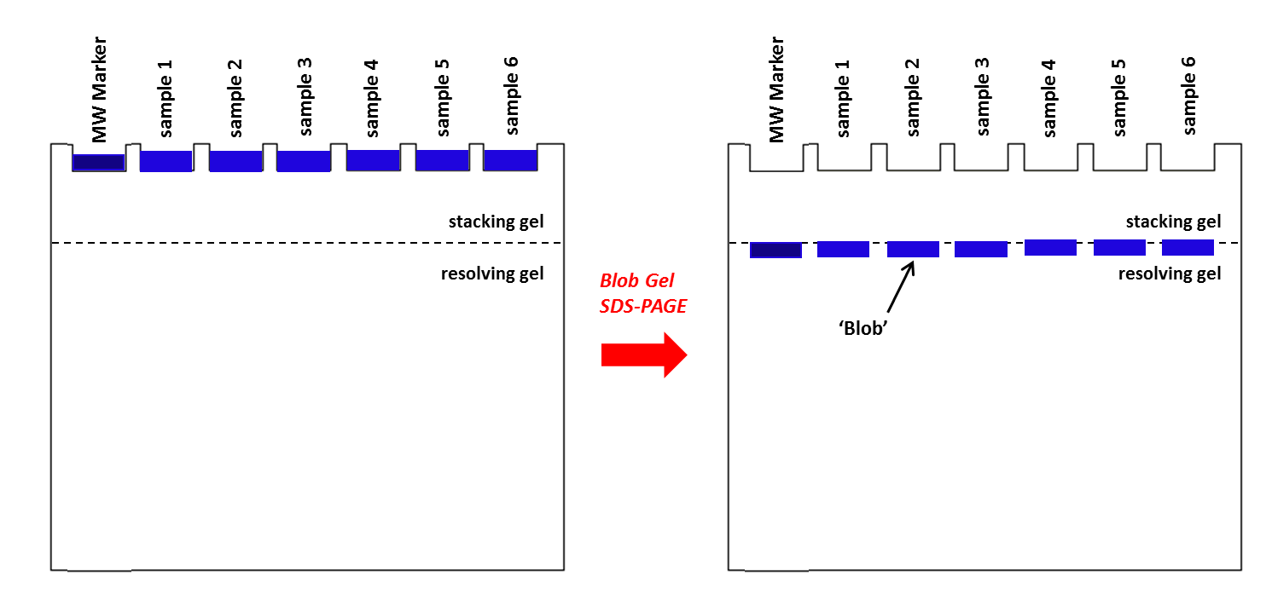
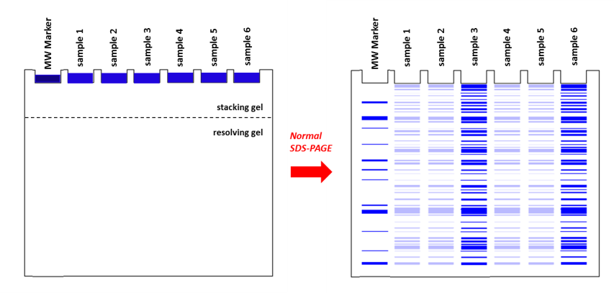

IMPORTANT GENERAL REMARKS:

- Self-cast SDS‐PAGE gels (e.g. using the Bio-Rad system) can vary in the size of the stacking gel, which can influence the required running time. The best approach is to keep a close watch on your gel in the final 5-10 minutes of running to stop it on time.
- Using a pre-cast NuPAGE gradient gel (lacking a distinct stacking gel) is not recommended.

Method
- Gel preparation
Prepare a gel and running buffer, and assemble the gel in the minigel system according to the
Bio-Rad Gel electrophoresis protocol.

- Sample preparation
1. To run your samples you should have your sample as a mixture that contains:
- 10% 1M DTT
- 25% 4*LDS
- 65% Sample
2. Boil or heat your samples (90-100 ºC) for 3 minutes.
3. Samples can be stored at -20 ºC or -80 ºC prior to SDS-PAGE.

- Running the gel
- Load the appropriate amount of sample and adjust all samples to the same amount using 1* RSB
- Fill unused wells with 1x sample buffer.
- Run at 100 V for 20-25 min (depending on the size of the stacking gel) until the sample has just (completely) entered the separating/resolving gel(red line separated from the blue line).
Take care not to run the gel too long!
- Carefully transfer the gel to a clean, (for in-gel digestion purposes) keratin‐free container with ~ 50 ml Fixing Solution, and agitate gently on a rocking platform.
- Stain the gel for at least 4h(or O/N) with coomassie and destain with milli-Q until the background is clear again (O/N or one day)

Solutions
- 1 x Reducing Sample Buffer (1*RSB):
- 10% 1M DTT
- 25% 4* LDS or 4* laemmli
- 65% milli-Q

  - Fixing Solution:
  - 500ml ethanol (pure)
  - 35ml orthophosphoric acid (85%)
  - Add MilliQ water to a final volume of 1000 ml

  - Coomassie
  - 1.0g coomassie G-250
  - 340ml methanol
  - 35ml orthophosphoric acid (85%)
  - 150g ammonium sulfate
  - Add MilliQ water to a final volume of 1000 ml (Stir O/N)

Materials & Equipment
- Bio-Rad Mini-Protean 3 Unit and accessories
- Gel Loader Tips
- Keratin-free tray

