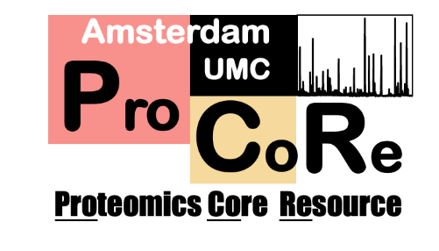

Suspension-trapping (S-Trap) sample processing
[Plate format]

Context: This protocol is adapted from the OPL S-Trap cartridge protocol. This method works with protein amounts from 10 µg down to 100 ng, but can be scaled further up or down, discussed under Scaling. This OPL protocol describes processing 10 µg protein in a sample volume of 20 µL and assumes prior experience with the cartridge-based protocol.

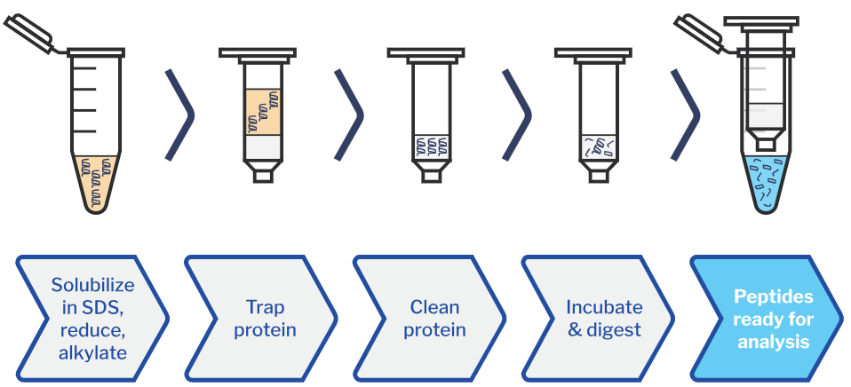
Schematic overview of protein suspension trapping workflow¹

Sample preparation protocol
Note: All steps on day 1 should be done in a flow cabinet to prevent keratin contamination. Book the flow cabinet in advance. Use the solutions and buffers supplied by OPL lab and only open them in the flow cabinet while wearing gloves and sleeves.
Solutions to be prepared can be found in Table 1.

Day 1: Sample lysis and digestion
- In case of precipitated protein, cell pellets or tissue: Lyse in 1X lysis buffer by vortexing thoroughly (10-20s). In case of liquid samples: add an equal volume of 2X lysis buffer.
- If the samples are viscous due to DNA, shear the DNA by sonication.
Branson cuphorn sonicator (CCA 1-59) at 100% amplitude, 20s pulse
- If needed, spin down insoluble material (5 min, 10,000 g) and transfer supernatant to new tube.
- The insoluble pellet may contain proteins of interest, omit this step unless there is a significant amount of debris.
- Check the protein concentration by BCA assay and normalize using 1X lysis buffer.
- This is also important to determine the amount of protein processed. Let us know the amount of protein in the samples. This protocol assumes 10 µg of protein in 20 µL volume (0.5 mg/mL), to adjust see Scaling
- SDS interferes with the BCA assay, so add the same volume of 1X lysis buffer to the BSA calibration curve as the volume of the tested samples. Add MQ to the test sample wells to keep the volumes consistent.
- Note: If you have sufficient material, run 5-20 µg on SDS-PAGE gel to visualize the protein content with Coomassie. Include the result in the PrOEF file. This is important to assess the quality and content of the sample.
- Pauze point: Samples may be frozen at this point at -80 °C.

- Transfer 20 µL sample containing 10 µg protein to an Eppendorf low-bind plate.
- Reduce/alkylate: Mix the 10X reductant and 10X alkylator in a 1:1 ratio and add 5 µL of the mix to all samples. Seal the plate, mix by vortexing and incubate at 37 °C for 1h.
Mixing can be done on the Bravo mixing module or plate mixer next to the BioTek.
- Add 2.5 µL acidifier (1.1% phosphoric acid final) and mix.
- Prepare an S-Trap plate sitting on a wash plate. Make sure unused wells are sealed with foil and mark the used wells on a sheet.
- Prepare binding/wash buffer in a reagent reservoir. Organize everything in the flowhood so you can transfer from reservoir sample plate S-Trap plate without contaminating any of them.
- Take up 165 µL binding/wash in a multichannel, pipet up and down twice to prevent dripping and transfer to the sample wells. Mix by pipetting up and down carefully. Transfer the mixed sample immediately to the S-Trap plate in two steps.
- Mixing carefully prevents backsplash into the multichannel and contaminating the samples. Transfer of the sample to the S-Trap plate is best done in two steps to prevent this from happening. Keep the multichannel set to 165 µL and pipette slowly.
- Centrifuge the S-Trap plate for 1-2 minutes at 400 g to trap proteins.
- Cover the plate with a lid before taking out of the flow cabinet.

- Wash the protein sample by adding 250 µL binding/wash buffer and centrifuging for
1-2 minutes at 800 g. Repeat 3 times for four total washing steps and discard the flowthrough after every step. Make sure all liquid is passed through after centrifuging.
- Again, set the multichannel to 125 µL and transfer in two steps.
- After the last washing step, centrifuge the S-Trap plate once more for 1 minute at 800 g to fully remove liquid.
- Transfer S-Trap plate to a different, dry wash plate.
- Digestion: Add 20 µL digestion solution to the S-Trap wells. Calculate the amount of trypsin needed to obtain a 1:10 trypsin-to-protein ratio and make the digestion solution correspondingly. Do not use less than 0.1 µg trypsin.
- Apply the digestion solution directly above the trapping matrix. If the solution is not applied evenly, tap the tubes on the table. Make sure the digestion solution makes contact with frit.
- When processing 100 ng protein, significant losses occur due to contact with plastic. In that case, add 0.015% LMNG to the digestion solution.
- Place the uncovered S-Trap plate on the wash plate in a box containing wet tissue. (Figure 1).
- Place the box in the water bath on a spacer, so that the box is above the water. (Figure 2).
Set the water bath temperature to 40 °C, which will result in an internal temperature of 37 °C in the S-Trap box. Set the shaking to its lowest setting (20 RPM).

Day 2: Peptide collection and storage
- Take the box from the incubator, open in the flow cabinet and transfer S-Trap plate to a low-binding Eppendorf plate.
- The wells will have dried out, so add 20 µL MQ to the wells before centrifugation. Cover the plate again with a lid and centrifuge for 1 min at 800 g to collect the digested peptides in the plate.
- Add 35 µL of 0.1% FA in water and centrifuge the samples at 1 min at 800 g.
- Add 35 µL of 0.1% FA in ACN and centrifuge the samples at 1 min at 800 g.
- Concentrate the peptides to dryness in a Speedvac at 45 °C (2-3h).
- Seal the plate with foil and store the dried peptides at – 20 °C in a marked box.

Required materials (Table 1)

Reagents/materials | Composition | Storage  (See S-Trap drawer)
1X lysis buffer | 5% SDS, 50 mM Tris pH 8.0  Make by diluting 2X lysis buffer 1:1 with MQ. | Prepare fresh
2X lysis buffer | 10% SDS (cat. #71729), 100 mM Tris pH 8.0 | OPL lab, 1 year at rt
10X reductant | 100 mM TCEP.HCl (cat. #) in 200 mM Tris.  Dissolve 28.6 mg TCEP.HCl in 1 mL Tris. | Prepare fresh  Chemical cabinet
10X alkylator | 400 mM CAA (cat. #) in MQ.  Dissolve 37.2 mg CAA in 1 mL MQ. | Prepare fresh  Chemical cabinet
Acidifier | Phosphoric acid (cat. #1.00573.1000) diluted to 12% with MQ | OPL lab, 1 year at rt
Tris stock | 1 M Tris pH 8.0 (cat. #1.08382.0500), adjusted with HCl | OPL lab, 6 months at rt  100 mL bottle and 1.5 mL aliquots in 15 mL tubes
Binding/wash buffer | 100 mM Tris pH 8.0 in 90% methanol  Make by diluting the above 1M Tris stock 10X in methanol (LCMS grade, Biosolve cat. #136878). | Prepare fresh  For small amounts: take one of the 1.5 mL Tris aliquots and fill tube up to 15 mL with methanol.
ABC solution | 50 mM ammonium bicarbonate in MQ  Dissolve 39.5 mg ABC in 10 mL MQ. | Prepare fresh
Detergent additive | 1% (w/v) Lauryl Maltose Neopentyl Glycol (Fisher Scientific, cat. #A50940) | OPL lab, freezer
Digestion solution | Sequencing grade trypsin (Promega cat. #V5111) in ABC.  Dissolve lyophilized trypsin (freezer 4) so that 20 µL of solution contains trypsin in a ratio of 1:10 (w/w) to your protein sample. For example, 10 µg sample requires 1 µg trypsin, so dissolve one 20 µg vial in 400 µL ABC,  giving 1 µg trypsin per 20 µL. | Prepare fresh
0.1% FA in water | 0.1% formic acid in water  (ULCMS grade, Biosolve cat. #069141 and #232141) | OPL lab, 6 months at rt  Bench, 250 mL bottle
0.1% FA in ACN | 0.1% formic acid in acetonitrile (ACN)  (ULCMS grade, Biosolve cat. #069141 and #012078) | OPL lab, 6 months at rt  Bench, 250 mL bottle
MQ | MilliQ water tapped from Purelab Flex (CCA 1-41). Bottle labeled "MQ" | OPL lab, 1 year at rt  Bench
Low-bind plates | Eppendorf twin.tec® PCR Plate 96 LoBind®  (cat. #0030129512) | Drawer Berend
S-Trap plates | Zymo-Spin I-96 Plate (Zymo research, C2004-SW) | Drawer Berend
Wash plates | 96 AbGene 1127, 1 mL deep well | OPL lab
PCR plate foil | Adhesive PCR Plate Foils (Thermo Fisher, cat. #AB0626) | Drawer Berend

Scaling (Table 2)
Sample | 1X lysis buffer (µL) | 2X lysis buffer (µL) | Reductant/ alkylator mix (µL) | Acidifier (µL) | Binding/wash buffer (µL)
Pelleted cells | 20 | — | 5 | 2.5 | 165
Protein pellet | 20 | — | 5 | 2.5 | 165
15 µL liquid | — | 15 | 7.5 | 3.75 | 250
30 µL liquid | — | 30 | 15 | 7.5 | 500
Scaling down
If you are processing 1 µg of protein or less, lower the trypsin amount to 0.1 µg per sample, which is the lower limit. Add 0.015% LMNG to the digestion buffer.
Scaling up
When scaling up the amount of protein processed, you only have to increase the amount of trypsin in the digestion buffer, all volumes can remain the same.
However, when working with a different starting volume than 20 µL sample (e.g. very diluted samples), some steps need to be adjusted (Table 2):
For reduction and alkylation, the amount of reagent mix is always 5 µL per 20 µL sample volume.
For acidification, the amount of acidifier is always 2.5 µL per 20 µL sample volume.
For adding binding/wash buffer, the amount of binding/wash buffer added is at least 6X the sample volume, up to 9X (initial volume plus other reagents)
If you want to follow this protocol without adjustment (10 µg protein, 20 µL lysate volume):
Try to aim between 1 and 2 mg/mL protein during lysis, determine protein concentration using BCA and make samples for proteomics by diluting to 0.2 mg/mL with 1X lysis buffer. Store the (concentrated) leftover lysate at -80 °C.

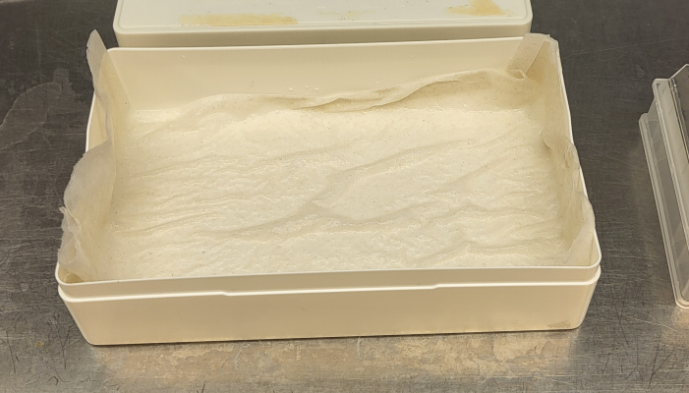
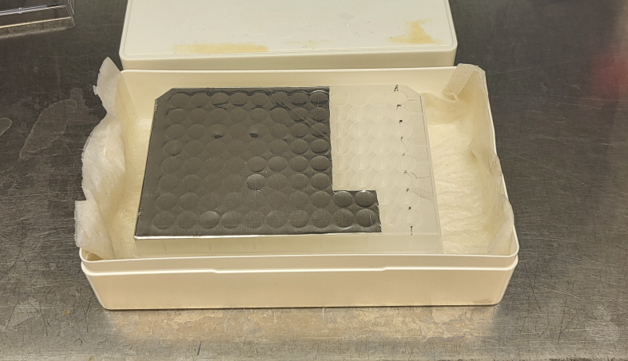
Figures
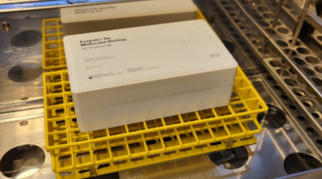
Figure 1: S-Traps with open caps in box.
Figure 2: Closed box in incubator.

